UML diagrams for a Python implementation of Blackjack
Component Diagram
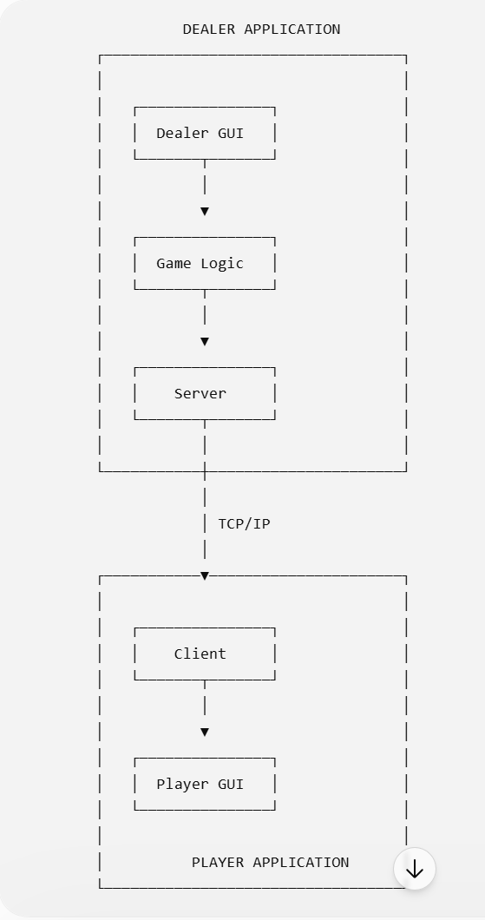

Initial Expanded Component Diagram
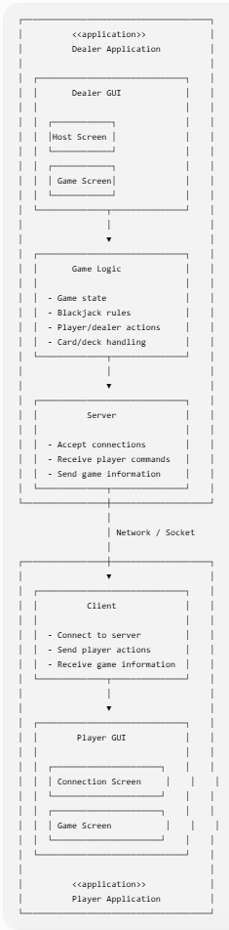
Sequence diagram of a dealer hosting a game and a player joining it
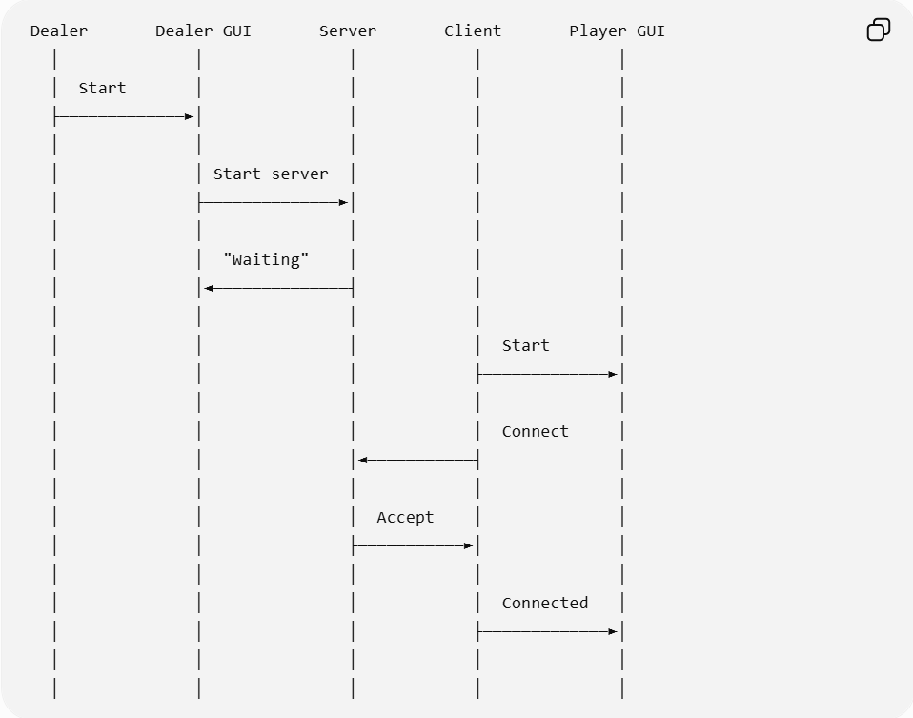

Sequence diagram of a player taking a hit action
